**CMSC430 Final Project**

**Approach:**

Before beginning this project, I watched the 4 part video series on Semantic Analyzers. I then read Chapter 7 of Mogensen’s Textbook. After going through all of the assigned material, I started by importing my project 2 code to the project 4 skeleton code. I then made the necessary changes to types.h, types.cc, scanner.l, and parser.y according to the project requirements, starting from the elements evaluated from the bottom of the parse tree and working my way up. After each change to the code, I checked my work with a specific test plan to test that change. Unfortunately, I was unable to get the case statement working.

**Test Cases:**

**Test Case 1: Using Boolean Expression with Arithmetic Operator - SUCCESS**

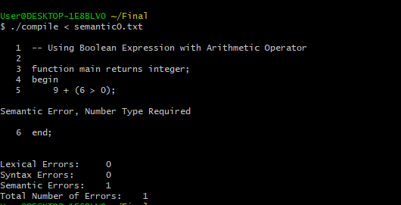

**Test Case 2: Using Real Operands with Remainder Operator**

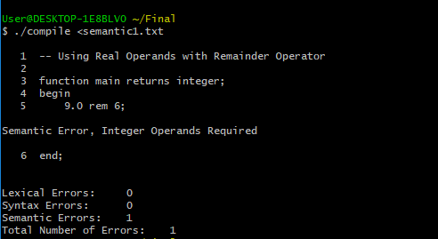

**Test Case 3: Using Boolean Expression with Relational Operator**

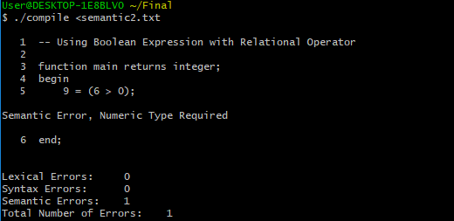

**Test Case 4: Using Arithmetic Expression with Logical Operator**

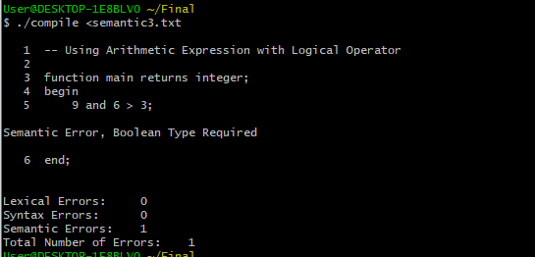

**Test Case 5: Conditional Expression Type Mismatch**

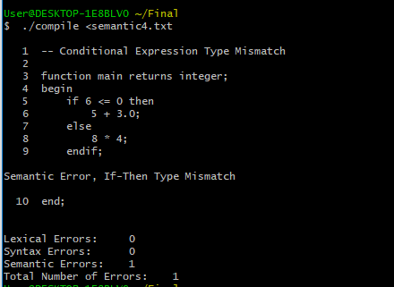

**Test Case 6: If Condition Not Boolean**

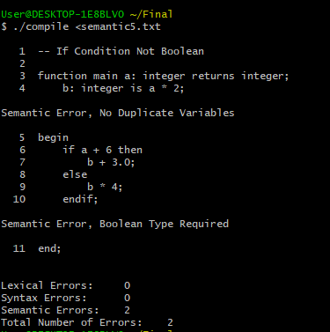

**Test Case 7: Narrowing Variable Initialization**

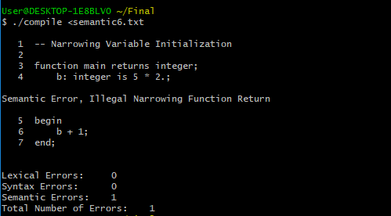

**Test Case 8: Variable Initialization Mismatch**

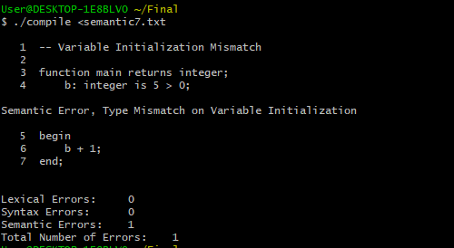

**Test Case 9: Undeclared Local**

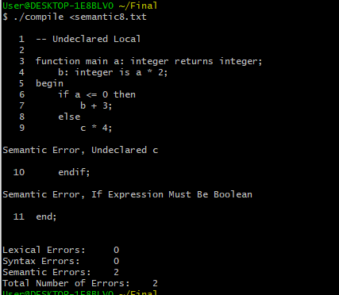

**Test Case 10: Duplicate Identifier**

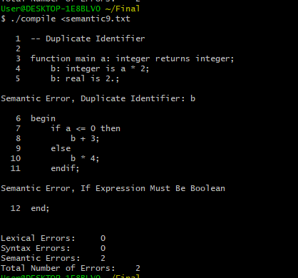

**Test Case 11: Narrowing Function Return**

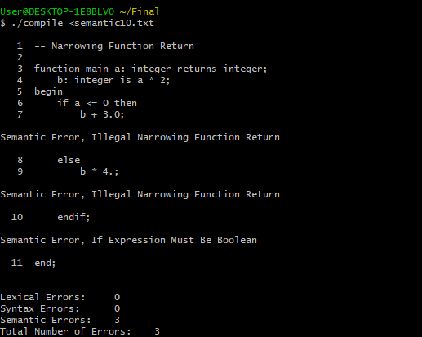

**Test Case 12: Test of Non Integer Case Expression - FAIL**

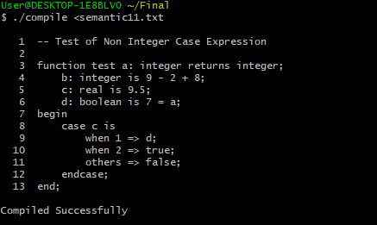

**Test Case 13: Test of Case Types Mismatch**

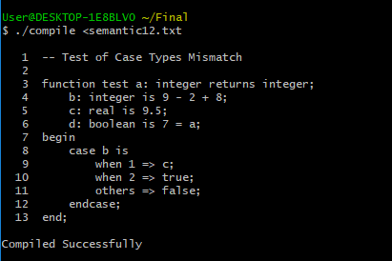

**Test Case 14: Using Real Operands with Remainder Operator**

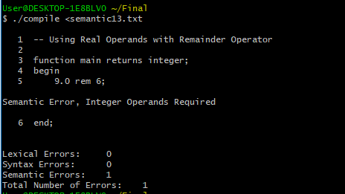

**Test Case 15: Function with a Boolean in Reduction List**

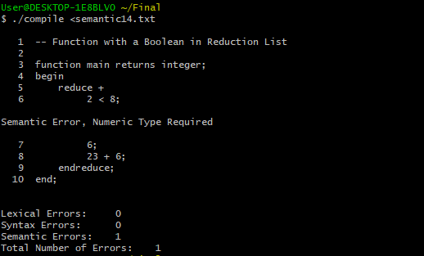

**Test Case 16: Multiple Semantic Factors**

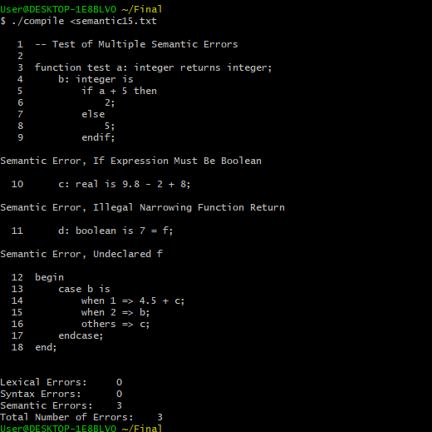

**Lessons Learned:**

This project taught me the concepts of type checking, type coercion, narrowing, and widening. Throughout the course of Compiler Theory and Design, I have learned how to use Flex, Bison, and Cygwin Terminal and learned the basics of compiling lexical, syntactical, and semantic analyzers.

I had a very hard time with the case statement and was not able to make it work, but not for lack of trying. I hope that after the deadline I will be able to obtain the correct methods in which to perform all of the type checking.